Wholesale customer

Data analysis

1.Introduction

Wholesale marketing refers to the process of selling goods or merchandise to retailers, industrial, commercial, institutional, or other professional business users. It involves selling products in bulk quantities at a reduced price compared to retail. The primary objective of wholesale marketing is to facilitate the distribution of products in large quantities and at discounted rates to businesses, which then sell these products to consumers at a higher price, making a profit.

1.1overview

Wholesale marketing involves the sale of goods or merchandise to retailers, industrial, commercial, institutional, or other professional business users. Wholesalers act as intermediaries between manufacturers or producers and these various buyers. They purchase products in bulk quantities from manufacturers and sell smaller quantities to retailers or other businesses at a slightly higher price, allowing both the wholesaler and the retailer to make a profit.

1.2 purpose

In essence, wholesale marketing plays a crucial role in the supply chain, ensuring the efficient movement of goods from manufacturers to end consumers. It serves as a bridge between production and consumption, providing benefits to both producers and retailers while fulfilling the needs of the market.

2.problem statement

One of the significant challenges in wholesale marketing revolves around the evolving landscape of consumer behavior and market dynamics, leading to several issues that the industry needs to address:

**Changing Consumer Preferences and Demands:** The continuous evolution of consumer preferences, demands, and shopping behavior poses a challenge for wholesalers. They must constantly adapt to these shifts, which can make it difficult to predict which products will be in demand and in what quantity, impacting inventory management and sales strategies.

**Competition and Market Saturation:** The wholesale market is highly competitive, with numerous players vying for attention. As a result, it becomes challenging for wholesalers to differentiate themselves, especially in an increasingly crowded market. The intense competition can drive down profit margins and necessitate innovative strategies to stand out.

**Technological Advancements and Digital Disruption:** The digital revolution has transformed the way goods are bought and sold. E-commerce, digital marketplaces, and direct-to-consumer models have disrupted traditional wholesale processes. Wholesalers need to adapt by incorporating digital strategies, improving online presence, and streamlining digital supply chain management to remain competitive.

**Supply Chain Disruptions and Global Challenges:** Supply chain disruptions, influenced by global events such as pandemics, trade wars, natural disasters, or geopolitical tensions, can significantly impact wholesale marketing. Issues like transportation delays, material shortages, or fluctuating import/export regulations can disrupt the flow of goods and inventory management.

**Margins and Pricing Pressures:** Wholesale businesses often operate on tight margins. External pressures, such as price fluctuations in raw materials, transportation costs, or even regulatory changes, can affect these margins, making it challenging to maintain profitability.

**Sustainability and Ethical Concerns:** As consumers become more conscious of environmental and ethical considerations, wholesalers face increasing pressure to ensure their supply chain is sustainable and socially responsible. This includes managing waste, reducing carbon footprint, and ensuring fair labor practices in the production process.

**Data Management and Analytics:** With the abundance of data available, wholesalers face the challenge of harnessing this information effectively. They need to leverage data analytics for better demand forecasting, inventory management, and understanding consumer behavior, but doing so requires investing in the right technology and expertise.

Addressing these challenges requires adaptability, innovation, and a proactive approach to meet the changing demands of the market while ensuring the efficiency and sustainability of the wholesale marketing industry.

2.2 empathy map

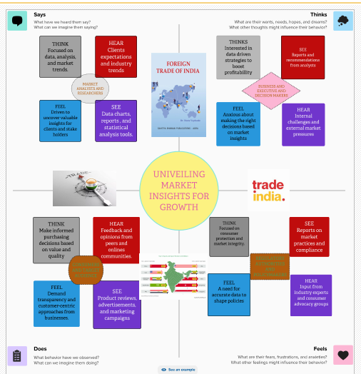

2.3 ideation and brain storming

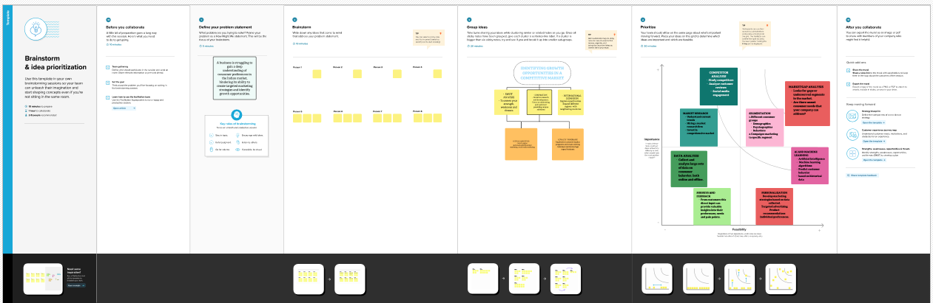

3.result analysis



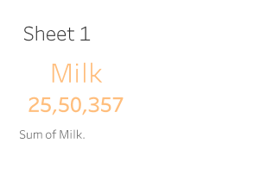

Range of milk

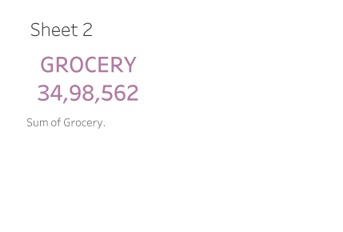

Sum of grocery

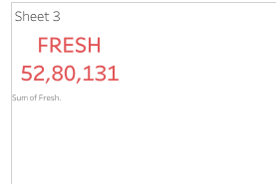

Sum of fresh

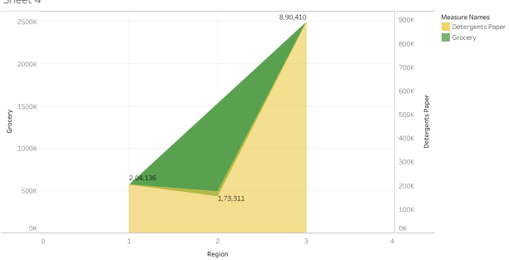

Regionwise grocery and

Detergent papers

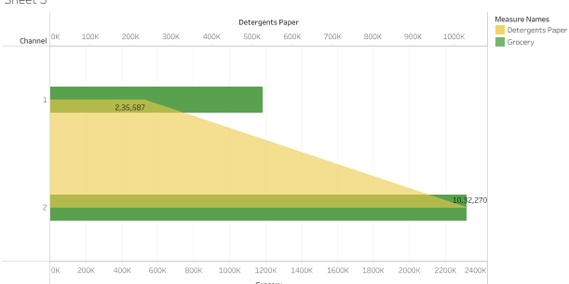

Channelwise grocery and detergent paper

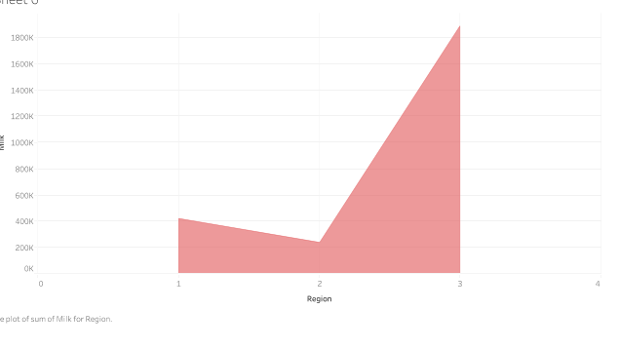

Regionwise milk

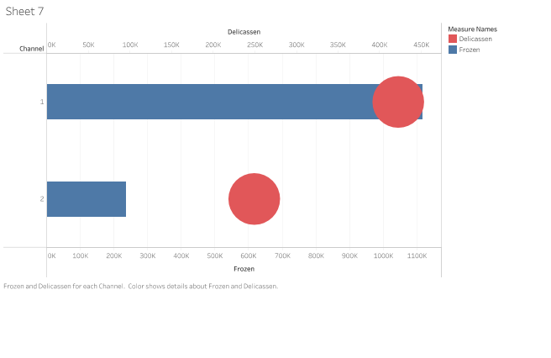

Channelwise frozen and

delicassen

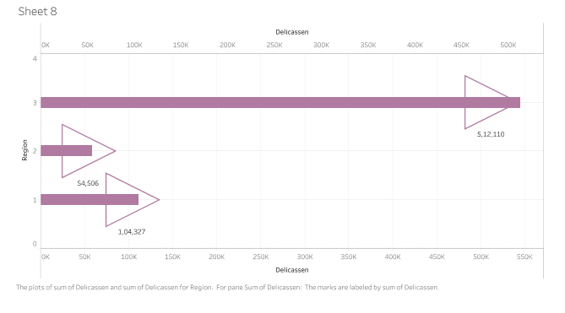

Region of delicaessan

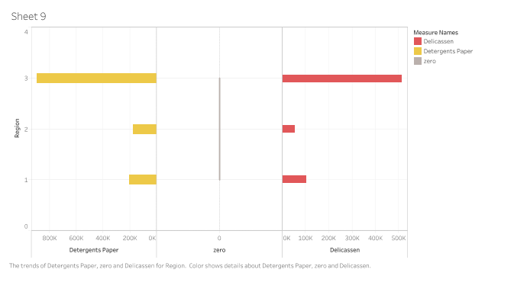

Regionwise detergents paper and delicassen

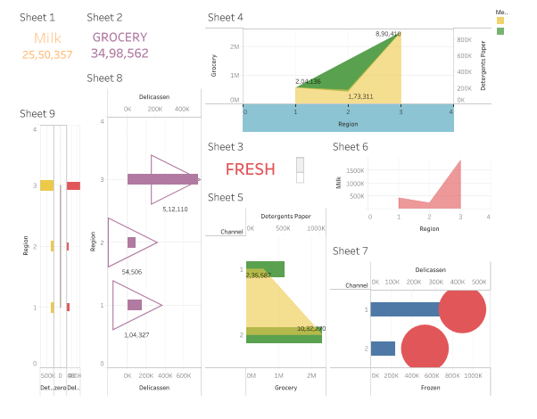

Data about wholesale market analysis

Story about wholesale customer data

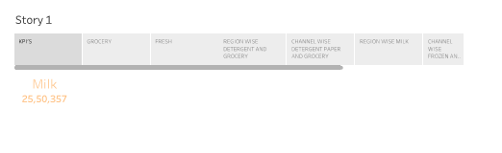

Sales of milk



Sales of groceries

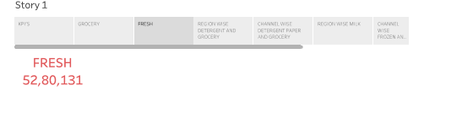

Sales of fresh

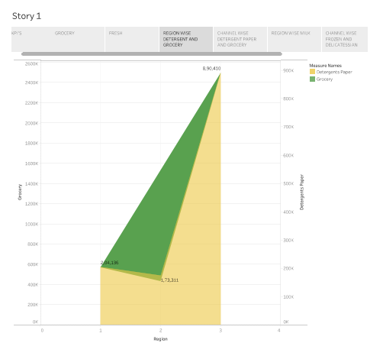

Regionwise sales between detergent paper and grocery

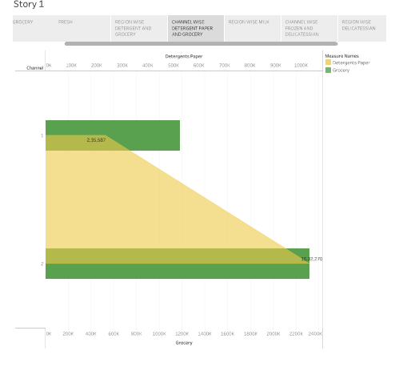

Channelwise sales between grocery

And detergents paper

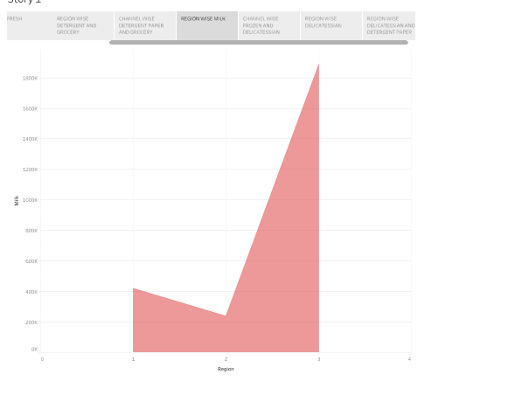

Regionwise milk

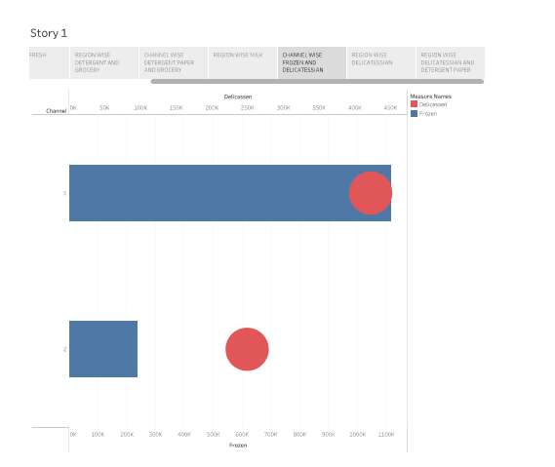

Channelwise sales in frozen and delicassen

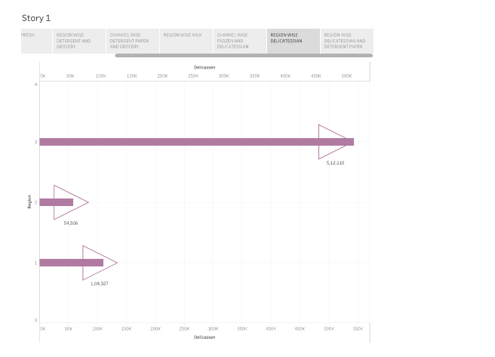

Regionwise sales in delicassen

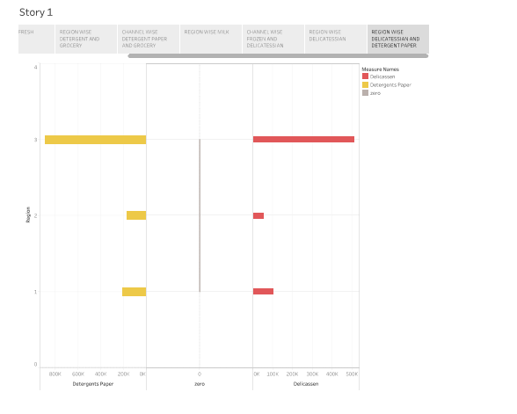

Regionwise sales in detergents paper

Wholesale marketing offers several advantages for businesses involved in selling products. Some of the key advantages include:

**Economies of Scale:** Buying and selling in bulk often allows for reduced per-unit costs due to economies of scale. Larger quantities mean lower production costs and higher profit margins.

**Increased Sales:** Wholesale marketing allows companies to reach a broader audience by selling their products in bulk to retailers, who then distribute them across different regions. This can lead to increased sales volume.

**Streamlined Distribution:** By selling in bulk to retailers or other businesses, wholesalers can streamline the distribution process. They can deliver large quantities of products to multiple locations more efficiently than if each retailer sourced the goods individually.

**Relationship Building:** Establishing relationships with retailers and other businesses through wholesale marketing can be mutually beneficial. It can lead to long-term partnerships, loyalty, and potential opportunities for exclusive deals or collaborations.

**Focus on Core Competencies:** Wholesaling allows companies to focus on their core strengths, such as manufacturing or sourcing products, without the need to manage individual retail sales. This specialization can lead to increased efficiency.

**Negotiating Power:** Wholesalers, due to the volume of goods they handle, often have more leverage in negotiating prices and terms with suppliers, which can further reduce costs.

Wholesale marketing is a significant component of many industries, and these advantages highlight why many businesses choose to engage in this type of marketing and distribution.

Disadvantages

Wholesale marketing offers numerous benefits, but it also has some disadvantages. Here are a few:

1. **Lower profit margins:** Selling in bulk at wholesale prices typically means lower profit margins per unit compared to retail sales. Wholesalers often trade higher volume for reduced margins, which might impact overall profitability.
2. **Dependence on few clients:** Wholesale businesses often rely on a limited number of major clients or retailers. Losing a key client can significantly impact the business, leading to fluctuations in sales and revenue.
3. **Large inventory management:** Managing a large inventory can be costly and challenging. Wholesalers need to store, handle, and manage a wide variety of products, which involves significant operational costs, such as storage space, maintenance, and potential inventory write-offs for obsolete items.
4. **Cash flow challenges:** Wholesale businesses often provide credit to clients, allowing them to pay after receiving the goods. This can lead to cash flow issues as the business has to manage its own expenses while waiting for payments from buyers.
5. **Market fluctuations:** Wholesale markets are subject to market trends and economic shifts. Changes in consumer demand, industry trends, or the introduction of new technologies can significantly impact sales and potentially lead to surplus inventory if not managed properly.
6. **Higher competition:** The wholesale market can be highly competitive. Competing on price alone might lead to a "race to the bottom," where profit margins shrink further, making it harder for businesses to sustain themselves without significant volume.
7. **Logistics and transportation costs:** Shipping and transportation costs for bulk goods can be substantial. Managing these costs, especially if they're subject to fluctuations, can affect the overall profitability of the wholesale business.
8. **Risk of product obsolescence:** Wholesalers might face challenges when dealing with products that become obsolete due to technological advancements, changes in consumer preferences, or market saturation. This can result in inventory write-offs and financial losses.
9. **Complex sales negotiations:** Negotiating deals with retailers or large buyers can be complex and time-consuming. Wholesale businesses might have to offer better terms, pricing, or services to secure contracts with major clients, adding to the operational complexities and potentially reducing profitability.

Understanding and effectively managing these disadvantages is crucial for the success of any wholesale business. Mitigating risks, optimizing inventory management, and exploring diverse revenue streams can help counteract some of these challenges.

Application

Wholesale marketing plays a crucial role in the distribution and sale of goods, serving as a vital link between manufacturers and retailers. Some of the key applications of wholesale marketing include:

1. **Bulk Sales to Retailers:** Wholesalers buy goods in large quantities from manufacturers or producers and sell them in smaller quantities to retailers. This bulk purchasing allows wholesalers to negotiate better prices and terms, providing cost-effective solutions to retailers.
2. **Distribution Channel Management:** Wholesalers manage the distribution process by efficiently storing, sorting, and delivering products to retailers. They ensure that products reach the market promptly, which is essential in meeting consumer demands.
3. **Market Access:** For small retailers or businesses, accessing manufacturers directly might be challenging due to volume requirements or geographic barriers. Wholesalers act as intermediaries, providing smaller businesses access to a wide range of products from various manufacturers.
4. **Price Negotiation and Bargaining:** Wholesalers have the advantage of buying in bulk, enabling them to negotiate prices with manufacturers. This helps in setting competitive prices for retailers while maintaining profitability for both the wholesaler and the retailer.
5. **Risk Mitigation:** Wholesalers help in mitigating risks for both manufacturers and retailers. For manufacturers, they provide a consistent market for their products, and for retailers, they reduce the risk associated with holding excess inventory.
6. **Market Information:** Wholesalers often have a deep understanding of market trends, demands, and consumer behavior. This information is valuable for both manufacturers and retailers in adapting their strategies and product offerings.
7. **Logistics and Inventory Management:** Wholesalers play a crucial role in managing inventory and the logistics of product delivery. They optimize inventory levels, reducing carrying costs and ensuring products are readily available to meet market demands.
8. **Product Assortment and Packaging:** Wholesalers often customize assortments or packages of products based on the specific needs of retailers. They might bundle various items or create specific packaging suitable for retailers and consumers.
9. **Credit Facilities and Financing:** Wholesalers might extend credit facilities to retailers, offering favorable payment terms which can be beneficial for retailers managing their cash flow.
10. **After-sales Support:** In some cases, wholesalers may also provide after-sales support, guidance, or services, particularly in industries where additional technical expertise or assistance is needed.

These applications demonstrate the integral role of wholesale marketing in facilitating the movement of goods from manufacturers to end consumers, optimizing the distribution process for various stakeholders involved in the supply chain.

Conclusion

Wholesale markets play a pivotal role in the global economy by serving as hubs for the distribution and exchange of goods between manufacturers, producers, and retailers. These markets facilitate the bulk sale of products, offering economies of scale, competitive pricing, and a centralized location for transactions. The significance of wholesale markets can be summarized in several key points:

1. **Economic Importance:** Wholesale markets contribute significantly to the economy by efficiently connecting producers and buyers. They support businesses by providing access to a wide variety of products at competitive prices, enabling retailers to stock their shelves with a diverse range of goods.
2. **Supply Chain Efficiency:** These markets streamline the distribution process, reducing logistical complexities by consolidating goods from various sources into a central location. This helps in managing inventory, reducing transportation costs, and ensuring a consistent supply of products to retailers.
3. **Market Dynamics:** Wholesale markets are dynamic environments where supply and demand interact, influencing pricing, product availability, and market trends. They often serve as indicators of consumer preferences, seasonal demands, and emerging trends in various industries.
4. **Networking and Relationships:** They offer a platform for networking, fostering relationships between suppliers, buyers, and other stakeholders in the industry. This facilitates the exchange of information, market insights, and business collaborations.
5. **Role in Local Communities:** Wholesale markets often become local hubs, attracting businesses and customers from surrounding regions. They can significantly contribute to the economic development of the area by creating job opportunities and stimulating trade.
6. **Technological Advancements:** With the advent of technology, many wholesale markets are transitioning to online platforms, improving accessibility and convenience for buyers and sellers, expanding their reach beyond traditional physical boundaries.

In conclusion, wholesale markets serve as essential intermediaries in the supply chain, ensuring the smooth flow of goods from producers to consumers. They play a critical role in driving economic growth, fostering business relationships, and adapting to technological advancements to meet the evolving needs of the market. Their adaptability and responsiveness to changing market demands remain crucial in sustaining their relevance in the ever-evolving global economy.

Futurescope

The wholesale market sector is an integral part of the economy, acting as a bridge between manufacturers or producers and retailers. It encompasses a wide range of industries, from goods like electronics, clothing, and groceries to specialized goods used in manufacturing and construction. The future scope for the wholesale market appears promising, driven by several trends and opportunities:

1. **E-commerce Integration:** Wholesale markets are increasingly embracing digital platforms and e-commerce. The future lies in efficient online platforms that facilitate B2B transactions, making it easier for businesses to order and manage inventory.
2. **Technological Advancements:** Automation, AI, and data analytics are revolutionizing the wholesale market. Predictive analytics and machine learning are used for demand forecasting, inventory management, and supply chain optimization, improving efficiency and reducing costs.
3. **Supply Chain Resilience:** The pandemic highlighted the importance of supply chain resilience. Future wholesale markets will focus on diversifying suppliers, employing agile inventory management, and ensuring flexibility to adapt to changing market demands.
4. **Sustainability and Ethical Practices:** There's an increasing emphasis on sustainable practices and ethical sourcing. Wholesale markets will likely see a shift towards eco-friendly products, responsible sourcing, and transparent supply chains.
5. **Globalization:** With the world becoming more interconnected, wholesale markets will continue to expand globally. This expansion provides opportunities for businesses to access a broader range of products and markets.
6. **Personalization and Customization:** Tailoring services and products to meet specific customer needs is becoming a significant trend. Wholesale markets will likely move towards offering more personalized and customizable solutions.
7. **Health and Wellness Products:** As the focus on health and wellness grows, the wholesale market will see an increased demand for products such as organic foods, nutritional supplements, and eco-friendly products.
8. **Diversification of Product Range:** Wholesale markets will diversify their product offerings, potentially including innovative technology, unique niche products, and other emerging market trends.
9. **Direct-to-Consumer (DTC) Trends:** Some wholesalers might explore direct-to-consumer models, cutting out intermediaries to reach end consumers, bypassing traditional retail channels.
10. **Regulatory Changes:** Keeping up with evolving regulations and compliance standards is crucial. Wholesale markets need to adapt to changing trade policies, tariffs, and industry standards to ensure compliance and sustainability.

The future of wholesale markets is undoubtedly shaped by technological advancements, changing consumer preferences, and global trends. Adapting to these changes, integrating technology, and focusing on sustainability will be key for success in the evolving wholesale industry.

Appendix

An appendix about wholesale marketing could include various supplementary materials to support and enhance the understanding of wholesale marketing strategies, data, or case studies. Here are some items you might consider including in an appendix on wholesale marketing:

1. **Market Research Data:** Statistical data, graphs, or charts that provide insights into market trends, consumer behavior, or industry statistics relevant to wholesale marketing.
2. **Case Studies:** Detailed accounts of successful wholesale marketing campaigns or strategies, illustrating their effectiveness and the results achieved.
3. **Sample Wholesale Marketing Plans:** An outline or examples of comprehensive marketing plans specifically designed for wholesale businesses.
4. **Wholesale Pricing Models:** Detailed explanations or examples of different pricing strategies used in wholesale marketing, such as cost-plus pricing, competitive pricing, or value-based pricing.
5. **Supplier and Vendor Contracts:** Sample contracts or agreement templates commonly used in the wholesale industry. These could include terms of service, terms and conditions, or partnership agreements.
6. **Distribution Strategies:** Information on various distribution channels, logistics, or supply chain management approaches pertinent to wholesale marketing.
7. **Customer Relationship Management (CRM) Systems:** Information on software or tools designed for managing wholesale customer relationships, such as CRM platforms specific to the wholesale industry.
8. **Trade Show Materials:** Brochures, flyers, or information related to relevant trade shows, where wholesalers can exhibit their products and network within the industry.
9. **Legal and Regulatory Information:** Details on legal requirements, regulations, and compliance standards that are essential for wholesale businesses to operate lawfully.
10. **Glossary of Wholesale Marketing Terms:** Definitions of key terms and jargon commonly used in wholesale marketing to help readers better understand the specific terminology.

Remember, the content in the appendix should supplement and provide additional context or details to the main body of the document. Each of these items should be relevant and directly support the information provided in the main text.